MPM containing anthracene derivatives
Frangula alnus

Кора крушины - Cortex Frangulae Buckthorn bark - Cortex Frangulae

BКрушина ольховидная - Frangula alnus Mill.Buckthorn - Frangula alnus Mill. (syn. Rhamnus frangula L.) (Syn. Rhamnus frangula L.)

Семейство крушиновые - Rhamnaceae Buckthorn family - Rhamnaceae

Кора крушины - Cortex Frangulae
Botanical Origin.—Frangula alnus Mill. (Rhamnus frangula L). (Engl. — Buckthorn Bark, Alder Buckthorn, Frangula Bark; Ukr. — Крушина ламка; Rus. — Крушинаольховидная). Family – Rhamnaceae.
Part Used.—Cortex Frangulae consists of the dried, whole or fragmented bark of the stems and branches of Frangula alnus Mill. (Rhamnus frangula L), Rhamnaceae.
Habitat.—Common in the hedges, damp woods and bushes of western and central Europe, buckthorn is collected mainly in eastern European countries from the Balkans to Poland.
Plant.—Buckthorn is a 3 to 5 m smooth, thornless, arborescent shrub with alternate and ovate leaves. These have parallel secondary veins, which curve as they meet the edge of the blade. The leaves are broadly ovate in outline, obtuse at apex and entire or slightly sinuate along the margin. The flowers, grouped at the base of the leaves, are small and greenish-white. The flowers are hermaphrodite, pentamerous and arranged in axillary clusters of 2 or 3. The fruit is a drupe, red at first, then black at maturity, with two or three seeds.

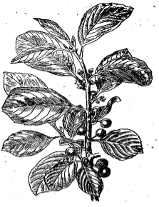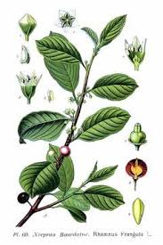

Fig. Frangula alnus

Adulteration.—Occasionally, with the bark of various species. Most often, these adulterants can be detected without difficulty based on their different macroscopic and microscopic features, such as the presence of sclereids or large single crystals or the absence of anthracene derivatives.

Table. Distinguishing diagnostic characters of Frangula alnus and its adulterants

 | Bark | Leaves
Frangula alnus Mill. | the grayish-brown or dark brown outer surface is wrinkled longitudinally and covered with numerous grayish (white), transversely elongated lenticels | simple, alternate, ovate, with parallel secondary veins (6-8 pairs), which curve as they meet the edge of the blade; broadly ovate in outline, obtuse at apex and entire or slightly sinuate along the margin
Rhamnus cathartica L. | the branches glossy, glabrous or occasionally pubescent and end in a thorn; blackish on the trunks, reddish-gray or brown on the branches | ovate or elliptical, finely serrate with 2 to 3 lateral ribs curved towards the midrib; clustered on the older branches, opposite on the younger ones
Sorbus aucuparia L. | smooth and pale gray, later becoming vertically fissured and blackish | odd-pinnate with 5 to 11 (9-15) almost sessile leaflets; oblong-lanceolate, irregularly thorny-tipped and serrate, pubescent or almost glabrous
Viburnum opulus L. | greenish gray sometimes with crooked longitudinal wrinkles and small brown-coloured lenticels | opposite, simple, petiolate, broadly ovate, palmately-veined and prominently 3-5-lobed, the lobes coarsely and irregularly toothed or nearly entire along the margin and acuminate at the apex, the middle lobe being frequently elongated
Alnus incana (L.) Moench. | gray smooth branches; the twigs glabrous, the young shoots pubescent; with light – coloured ovate lenticels | simple, the obovate dark green, with the teeth serrulate, obtuse or some of them acute at the base, dark green above, pale or glaucous and pubescent, at least on the veins beneath, the veins prominent on the lower surface

MPM Description.—According to the EP, The bark occurs in curved, almost flat or rolled fragments or in single or double quilled pieces usually 0.5 mm to 2 mm thick and variable in length and width. The grayish-brown or dark brown outer surface is wrinkled longitudinally and covered with numerous grayish, transversely elongated lenticels; when the outer layers are removed, a dark red layer is exposed. The orange-brown to reddish-brown inner surface is smooth and bears fine longitudinal striations; it becomes red when heatedwith alkali. The fracture is short fibrous in the inner part. Odour distinct; taste slightly bitter.
Microscopical Characters.—Transverse sections exhibit the following microscopical structures:
1. Cork, an undulate layer of numerous layers of purplish-brown, to reddish-brown, tabular cork cells, containing a purple to purple-crimson or brown coloring matter.
2. Cork cambium of meristematic cells, mostly collapsed.
3. Cortex of an outer zone of collenchyma and an inner zone of several layers of thin-walled cells, some of which contain a brownish amorphous substance, others minute starch grains, still others rosette aggregates of calcium oxalate up to 25 µm in diameter.
4. Phloem, a broad region traversed by starch and active principle containing medullary rays that tend to converge in groups. The phloem patches between the medullary rays contain tangentially elongated groups of bast fibers having thick, strongly lignified, yellowish walls and narrow lumina. Each group of bast fibers is more or less surrounded by a layer of crystal fibers, the cells of which contain monoclinic prisms of calcium oxalate up to 15 µm in diameter. The medullary rays are 1 to 3 cells in width.
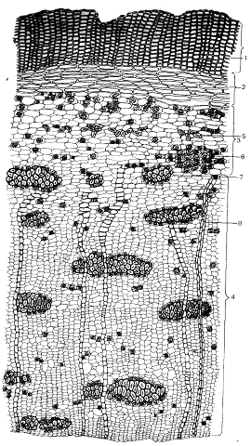
Fig. Cross section of Frangula alnus bark. 1 – Cork; 2 – collenchyma; 3 – primary bark; 4 – secondary bark; 5 – stone cells; 6 – aggregate crystals of CaC₂O₄; 7 – bast fibers surrounded by a layer of CaC₂O₄ crystals; 8 – medullary rays
Powdered Drug.—Distinguished from that of Cascara Sagrada chiefly by its absence of stone cells.
According to the EP, The powder is yellowish or reddish-brown. The powdered drug shows numerous phloem fibres, partially lignified, in groups with crystal sheaths containing calcium oxalate prisms, reddish-brown fragments of cork; fragments of parenchyma containing calcium oxalate cluster crystals. Sclereids are absent. The thick phloem fibers are surrounded by rows of cells each containing a prism of calcium oxalate and are separated by wide medullary rays consisting of one to three cells.
Constituents.—Frangula contains anthraquinone derivatives present mainly in the form of glycosides. In the dried drug, stored for over a year or heat treated, anthraquinone derivatives occur as mono- or biosidic anthraquinone glycosides. The rhamnoside franguloside, or frangulin, consisting of two isomers, frangulosides A and B, formed by partial hydrolysis of the corresponding rhamnoglucosides, glucofrangularosides A and E. The monosides are frangulin A (= emodin 6-0--L-rhamnoside) and frangulin B (= emodin 6-O--D-apioside). The fresh bark also contains anthranols and anthrones, which are unstable and readily oxidize to the corresponding anthraquinones; emodin-dianthrone, palmidin C, palmidine C-monorhamnoside and emodin-diantharone monorhamnoside, emodin-8-O-gentiobioside. Free aglycones are scarce (<0,1%) and mainly represented by emodin. Buckthorn bark also contains traces of cyclopeptidic alkaloids, flavonoids, and 3 to 8% l,8-dihydroxyanthraquinone derivatives.
According to the EP, it contains not less than 7.0 per cent of glucofrangulins, expressed as glucofrangulin A and calculated with reference to the dried drug.
Pharmacological Action. Uses.—Buckthorn bark is widely used as a laxative, in the crude form (herbal tea mixtures), as a powder, or as extracts, which are the ingredients of many proprietary drugs. It is sometimes combined with a spasmolytic agent, a bulk laxative, or both. When used crude, the mode of preparation of the infusion undoubtedly influences the final concentration in active principles. Normally these herbal teas are prepared by a five-minute decoction followed by a two-hour infusion.
Standardized drug Rhamnilum contains not less, than 55% of total anthraquinones content. The bark powder is an ingredient of Vikairum and Vikalinum, laxative and antihaemorrhoidal teas.
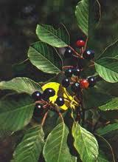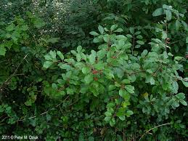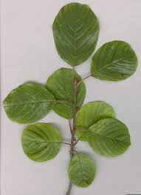
Frangula alnus (Rhamnus frangula)

Rhamnus cathartica

Плоды жостера слабительного - Fructus Rhamni catharticae Fruits rhineberry - Fructus Rhamni catharticae

Жостер слабительный - Rhamnus cathartica L. Rhineberry - Rhamnus cathartica L.
Семуйство крушиновые - RhamnaceaeBuckthorn family - Rhamnaceae
Botanical Origin.—Rhamnus cathartica L. (Engl. — Buckthorn Berries, Common Buckthorn;). Family – Rhamnaceae.
Part Used.—Fructus Rhamni catharticae consists of the dried ripe fruits of Rhamnus cathartica L., Rhamnaceae.
Habitat.—The plant is common all over Europe, Western Asia and North Africa.
Plant.—The plant occurs in a variety of forms, usually as a bush that is up to 3 m in height, but occasionally as a tree with a bent trunk that grows up to 8 m. The boughs are usually stiffly spread; the branches are more or less clearly opposite, glossy, glabrous or occasionally pubescent and end in a thorn. The leaves are clustered on the older branches, opposite on the younger ones. They are ovate or elliptical, finely serrate with 2 to 3 lateral ribs curved towards the midrib. The small, dioecious, greenish-yellow flowers are in axillary cymes. The calyx is fused, has 4 segments and droops. The petals are small and are on the edge of the calyx tube, which has short stamens. The ovary is 4-valved with a style that is divided in 4. The fruit is a peasized, black berry-like drupe. The seeds are 5 mm long and triangular with a narrow split, which separates slightly at the end and is surrounded by a cartiliginous margin.
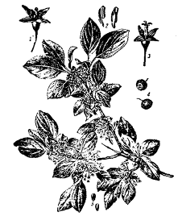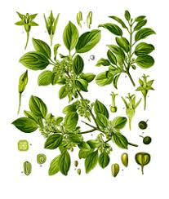

Fig. Rhamnus cathartica

MPM Description.—Entire, globoid or ovoid, 4 to 8 mm in diameter; externally purplish-black to very dusky red with a ring-like disk of 4-calyx teeth at the summit and with a short pedicel at the base, wrinkled in the dried state; internally exhibiting, when cut crosswise and examined with a hand lens, a greenish-yellow pericarp surrounding 4 locules, 2 or 3 of which contain a triangular-convex seed-like nutlet; odor faint, unpleasant; taste sweetish, then nauseating and bitter. It colours the saliva purplish-red. The unripe fruit which is to be rejected is dusky brown to weak olive green, with pedicel usually attached, very bitter and colours the saliva a greenish-yellow when masticated.
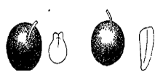

Fig. Fruits of Rhamni frangulae (left) andRhamni catharticae (right)

Powdered Drug.—The powder is dusky brown. Numerous fragments of epidermis and parenchyma, some of the parenchyma cells containing an amorphous substance which is coloured purplish-red or purplish-orange with chloral hydrate, others with rosette aggregates of calcium oxalate, up to 2 µm in diameter; fragments of sarcocarp of thin-walled parenchyma and secretion cells with oil contents, stone cells thick-walled from 35 to 75 µm in diameter with a reddish-brown amorphous content or monoclinic prisms of calcium oxalate, the latter up to 25 µm long; sclerenchyma fibers from endocarp long and thick-walled and associated with crystal fibers containing prisms of calcium oxalate; numerous fragments of endosperm the cells of which contain fixed oil and aleurone grains.
Constituents.—The fruits contain up to 4% of anthraglycosides (chrysophanol, rhamnocatharnin (glucofranguline), rhamnoxanthin (frangulin). The MPM contains frangula-emodin and a glycoside, rhamnicoside, which yields on hydrolysisrhamnicogenol (an anthraquinone derivative), glucose and xylose. Flavonoids and tannins also occur.
Pharmacological Action. Uses.—The drug has a laxative effect because of the anthraquinone content. Fruit decoction is used as a mild laxative for constipation and when soft stool is desired (hemorrhoids, after anal or rectal surgery). Often drug is an ingredient of laxative teas and herbal collections. The contraindications and side effects are the same as for other anthraquinone-containing drugs.
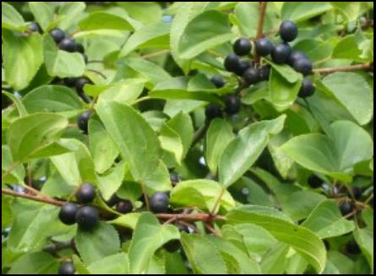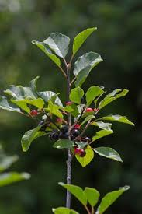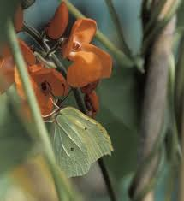

Aloe

The leaves of aloe tree fresh - Folia aloes Arborescens recens

AАлоэ древовидное - Aloe arborescens Mill.Aloe ree - Aloe arborescens Mill.

Семейство асфоделовые - Asphodelaceae Lily family - Liliaceae

Другие названия: Род алоэ представлен многолетними тропическими и субтропическими растениями с крупными толстыми сочными листьями. Botanical characteristics. Genus Aloe submitted perennial tropical and subtropical plants with large thick succulent leaves. В Африке стволы их достигают высоты 4 м, а листья длины до 65 см; обычно они скучены на верхушке ствола. In Africa, their trunks reach a height of 4 m, and the leaf length of 65 cm, they are usually crowded at the top of the barrel. Цветочная кисть высокая, длинная. Flower brush high and long. Цветки красные или желтые. The flowers are red or yellow. В диком виде не произрастает.
Distribution. In the wild do not grow. Возделывается в совхозах Закавказья. It is cultivated in the state farms in Transcaucasia. В зимнее время алоэ сохраняют в теплицах, а весной высаживают в грунт. In winter, keep aloe in greenhouses, and in spring planted in the ground. Из многочисленных видов алоэ возможна культура только алоэ древовидного, наиболее морозоустойчивого. Of the numerous species of aloe culture can only aloe tree, the most frost. Другие виды приживаются плохо. Other species take root poorly. Преимущественно во влажном субтропическом климате. Habitat. Mostly in humid subtropical climate. Заготовке подлежат хорошо развитые нижние и средние листья. Harvesting of raw materials. Billet to be well-developed lower and middle leaves. Сбор ведется путем отделения вместе с малосочными влагалищами, охватывающими стебель. The term of the raw materials in transit to the site of processing is not more than a day. Для получения сырья «Листья алоэ древовидного сухие» собранные листья консервируют по методу В.П.Филатова, выдерживая их в темноте при температуре 4-8°С в течение 12 суток, а затем сушат в вакуум-сушильных шкафах при температуре 75-80°С до остаточной влажности не более 10%. В настоящее время предложено сушить без вакуум-сушильных шкафов. At present there to dry without a vacuum drying ovens. Качество сырья «Листья алоэ древовидного сухие» регламентировано ВФС 42-2800-91. Листья алоэ содержат оксиметилантрахинон - алоэ-эмодин (около 2%) и другие антрапроизводные - алоин, наталоин, гомоната-лоин.
Plants.—The lily-like succulent-leafed rosette shrub (1) either does not have a stem or has a 25 cm stem. The stem has about 25 leaves in an upright dense rosette. The lanceolate leaf is thick and fleshy, 40 to 50 cm long and 6 to 7 cm wide at the base. The upper surface is concave, grayish-green, often with a reddish tinge, which sometimes appears in patches in the young plants. The leaf margin has a pale pink edge and 2 mm long pale teeth. The inflorescence is forked once or twice and is 60 to 90 cm high. The raceme is dense, cylindrical and narrows toward the top. The terminal raceme is up to 40 cm high while the lower ones are somewhat shorter. The bracts are almost white, and the flowers are yellow, orange or red, and are 3 cm long.
Aloe ferox (2) which yields Cape Aloe, is the loftiest of the whole genus. The leaves are lanceolate, glaucous, becoming reddish and produce spines from every part, but stouter, longer, sharper and more curved ones are produced along the purplish margins and in a line along the middle of both the ventral and dorsal surfaces.
The krantz aloe (3) develops into a multiheaded shrub up to 4 m high with striking grey green leaves arranged in attractive rosettes. The leaf margins are armed with conspicuous pale teeth, length up to 70 cm. The inflorescence is usually unbranched, with two to several arising from a single rosette.
Microscopical Characters.—The leaves of all species of the genus Aloe are of the succulent, xerophytic, centric type. Either of the plants furnishing the official drug has leaves which, when examined microscopically, exhibit the following structural peculiarities:
A covering layer or epidermis containing scattered stomata, each surrounded in Aloe ferox by four neighbouring cells. The outer walls of the epidermal cells are strongly cutinized. Beneath the epidermis is the mesophyll which is differentiated into an outer cortical and an inner central zone. The outer cortical zone comprises several layers of chlorenchyma cells containing chloroplasts; the inner (central) zone is composed of large, clear, thinner walled cells with abundant mucilage content. On the border of the clear central and outer cortical zones are to be noted fibrovascular bundles arranged in the form of an ellipse. Each of these is accompanied by a number of long, tubular, thin-walled pericyclic cells containing a bitter juice which, when inspissated, constitutes the drug. Raphides of calcium oxalate are present in both cortical and central zones of the leaf.
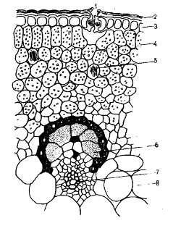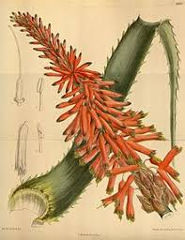
Fig. Cross section of Aloе arborescens leaf. 1 – Stomata; 2 – cuticle; 3 – palisade parenchyma; 4 – spongy parenchyma; 5 – raphides of CaC₂O₄; 6 – cells with aloine; 7 – fibrovascular bundle
MPM Description.— (1) Dark brown masses, slightly shiny or opaque with a conchoidal fracture, or a brown powder, soluble in hot alcohol, partly soluble in boiling water (the EP).
(2) Dark brown masses tinged with green and having a shiny conchoidal fracture, or a greenish-brown powder, soluble in hot alcohol, partly soluble in boiling water (the EP). It has a distinct sour odour and a nauseous, bitter taste.
Constituents.—(1) Anthracene derivatives : particularly anthrone-10-C-glycosyls, including aloin A, aloin B, 7-hydroxyaloins A and B, and 1,8-dihydroxy ions, including aloe-emodin, and 6'cinnamic acid esters of these compounds; 2-alkylchromones:including aloe resins B, C and D; flavonoids. It contains, according to the EP, not less than 28.0 per cent of hydroxyanthracene derivatives, expressed as barbaloin (C₂₁H₂₂O₉;M_{r} 418.4) and calculated with reference to the dried drug.
(2) Barbaloin (C₂₁H₂₀0₉), a pale yellow anthraquinone glucoside (pentoside), aloe-emodin, aloin (afrer hydrolisis of aloe-emodin), bitter resin; an isomeric substance termed -barbaloin. When barbaloin is boiled with alcohol acidified with hydrochloric acid, emodin (C₁₅H₁₀O₅) is yielded. The resin of Cape aloes consists of capaloresinotannol combined with paracoumaric acid. It contains, according to the EP, not less than 18.0 per cent of hydroxyanthracene derivatives, expressed as barbaloin (C₂₁H₂₂O₉; M_{r} 418.4) and calculated with reference to the dried drug.
(3) Oxymethylanthraquinone derivatives, aloe-emodin, C - glycoside aloin (aloe - emodin anthrone + arabinose), nataloin (anthrone + arabinose); also occur ferments, polysaccharides, resins, vitamins, organic acids.
Pharmacological Action. Uses.—Aloe anthranoids such as 1,8-dihydroxy - anthracene derivatives exert a laxative effect. The laxative action is due to anti-absorption osmotic properties. It is contraindicated in hemorrhoids, menstruation and pregnancy.
Effects of topical Aloe plants: Aloe vera depresses action potential generation and conduction at neuromuscular junction processes which result in analgesic and anti-inflammatory effects. Aloe vera increases collagen content of the granulation tissue and its degree of crosslinking to contribute to wound healing. Aloe vera acts as a modulatory system toward wounds with anti-inflammatory effects. The fresh leaf and the pulp of the leaf have been successfully used to increase the rate of healing of acute X-ray burns.
The fresh leaves (3) are the source of biogenic stimulants. These substances are produced in the shadow as a result of plant adaptation. Such medications (liquid extract for injections and aloe tablets) possess immunomodulating, bactericidic and anti-inflammatory activity and are used in ophtalmology, surgery, gastroentherology, dermatology. Combined drug Linimentum Aloes shows reparative action in burns. Succus aloes (leaf soap) due to its purgative, anti-inflammatory and bactericidic effects is used internally in gastroentherology and externally in dermatology (burn wounds and abrasions, skin disorders). Extracts from the leaves (3) have been widely investigated and shown significant wound healing, anti-bacterial, anti-ulcer, anti-inflammatory, anti-carcinogenic, hypoglycaemic and also alopoeic activity. The leaves have also been found to have purgative properties and the leaf sap is reported to relieve X - ray burns.
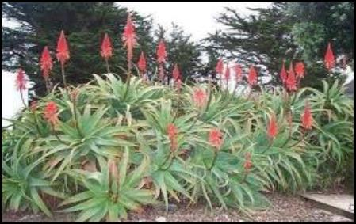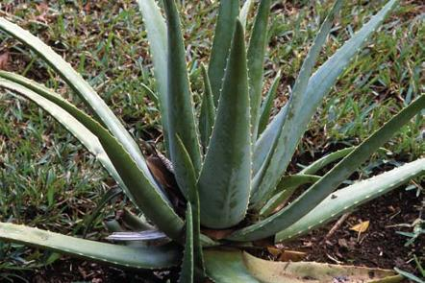

Hypericum perforatum
St. John's Wort herb - Herba Hyperici
St. John's wort (ordinary) - Hypericum perforatum L.
Mammal family - Hypericaceae
Botanical Origin.—Hypericum perforatum L. (Engl. — St.-John's wort;). Family – Hypericaceae.
Part Used.—Herba Hyperici consists of the whole or cut, dried flowering tops of Hypericum perforatum L., Hypericaceae, harvested during flowering time.
Habitat.—The plant is indigenous to all of Europe, western Asia and northern Africa, it grows in the neglected fields and along the country roads of Europe and North America. It has been introduced to eastern Asia, Australia and New Zealand, and it is cultivated in Poland and Siberia.
Plant.—The perennial plant is 30 to 60 cm and contains a long-living branched root and rhizome, which tapers toward each end. The reddish stem is erect, includes 2 raised edges and can reach 100 cm in height. The oval-shaped, translucent, punctate leaves are attached directly at the base and often covered in black glands. The golden yellow flowers are in sparsely blossomed terminal cymes. The 5 sepals are ovate-lanceolate to lanceolate and very pointed. The sepals are also smooth, serrate at the tip, and marked by many light and dark glands. The 5 petals and numerous stamens are fused into 3 bundles. The ovary has a broad or narrow oval shape. The fruit is a 3-valvular capsule, which is triangular and oval. The seeds are cylindrical and shortly pointed at both ends. The seeds are 1 to 3 mm long, either black or dark brown, and covered in small warts.

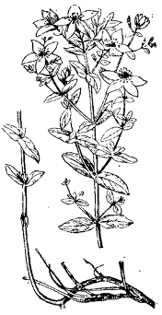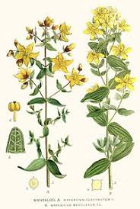
Fig. Hypericum perforatum
Adulteration.—Occurs relatively frequently with other Hypericum species, which can be recognized by their stem fragments. The most common adulterant Hypericum maculatum Crantz has quadrangular stems; the official stem with 2 longitudinal grooves.
MPM Description.—According to the EP, The branched and bare stem shows two more-or-less prominent longitudinal ridges. The leaves are opposite, sessile, exstipulate, oblong-oval and 15 mm to 30 mm long. The leaf margins show black glandular trichomes, and many small translucent, oil glands are present on the entire surface and are visible by transmitted light. The flowers are regular and form corymbose clusters at the apex of the stem. They have five green, acute sepals, with black secretory trichomes on the margins; five orange-yellow petals, also with black secretory trichomes on the margins; three staminal blades, each divided into many orange-yellow stamens and three carpels surmounted by red styles.
The flowers release an odourless red juice when squeezed, which tastes weakly bitter and irritating.
Microscopical Characters.—According to the EP, The powder shows fragments of polygonal cells of the epidermis with thickened and beaded walls and paracytic or anomocytic stomata; fragments of the leaf and sepal with large oil glands and red pigment cells; thin-walled, elongated cells of the petal epidermis with straight or wavy anticlinal walls; tracheids and tracheidal vessels with pitted walls and groups of thick-walled fibres; fragments of rectangular, lignified and pitted parenchyma; fibrous layer of the anther and elongated, thin-walled cells of the filament with a striated cuticle; numerous pollen grains with three pores and a smooth exine, occur singly or in dense groups, and calcium oxalate cluster crystals.
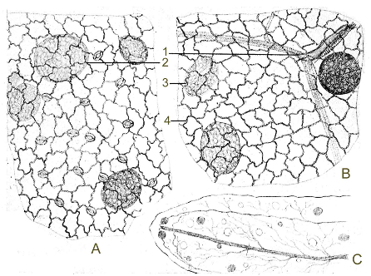
Fig. Hypericum perforatum leaf. A – Lower epidermis; B – Upper epidermis; C –Portion of a leaf under a magnifying glass. 1 – Oil gland near the vein; 2 – oil gland with pigment contents; 3 – oil gland with colourless contents; 4 – striated cuticle of epidermal cells
Constituents.—Anthracene derivatives (0.1-0.15%): favouring naphthodianthrones, especially hypericin, pseudohypericin. Flavonoids (2-4%): in particular hyperoside, quercitrin, rutin, isoquercitrin, and also biflavonolids including amentoflavone. Xanthones (0.15-0.72%): 1,3,6,7-tetrahydroxy-xanthone. Acylphloroglucinol hyperforin. Volatile oil: chief components aliphatic hydrocarbons, including, among others, 2- methyloctane, undecane, furthermore dodecanol, mono- and sesquiterpenes: α - pinene, caryophyllene, additionally also 2-methyl-3-but-3-en-2-ol. Procyanidines and other catechin tannins (6.5-15%). Caffeic acid derivatives: including chlorogenic acid.
According to the EP, It contains not less than 0.08 per cent of total hypericins expressed as hypericin, calculated with reference to the dried drug.
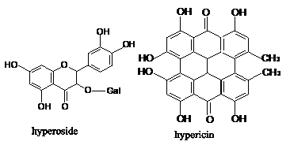
Pharmacological Action. Uses.—The flowering tops of Saint John's wort are widely prescribed, as a standardized extract, for the treatment of mild and moderate depression (antidepressant). Internally, the drug is used for psychovegetative disturbances, depressive moods, anxiety and nervous unrest. Saint John's wort itself is used for the same indications and to prepare wound-healing oil. Externally, the oily Hypericum preparations are used for treatment and post-therapy of acute and contused injuries and for first-degree burns. It is used in phytotherapy for their antiseptic and healing properties. It contains polycyclic quinones that are photodynamic sensitizers and antiviral agents. The infusion and decoction exhibit antimicrobial, anti-inflammatory, antihaemorrhage and astrigent action.
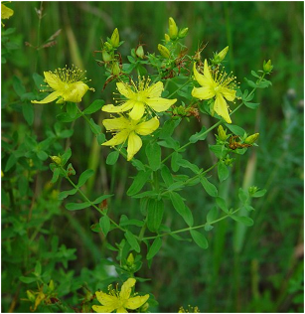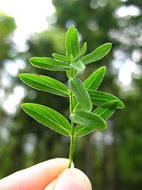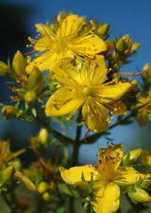

Rheum spp

The roots of the rhubarb - Radices Rhei

Ревень дланевидный тангутский - Rheum palmatum L. Tangut rhubarb - Rheum palmatum L. var. var. tanguticum Maxim tanguticum Maxim

Семейство гречишные - Polygonaceae Buckwheat family - Polygonaceae
Botanical Origin.—Rheum palmatum L. (Engl. — Turkey Rhubarb, Chinese Rhubarb) , Rheum officinaleBullion (Engl. — Medicinal Rhubarb ). Family – Polygonaceae.
Part Used.— Radices Rhei, according to the EP, consists of the whole or cut dried underground parts of Rheum palmatum L. or of Rheum officinale Bullion., Polygonaceae or of hybrids of these two species or of a mixture. The underground parts are often divided: the stem and most of the bark with the rootlets are removed.
Habitat.—China, Tibet, and Mongolia. The genus Rheum comprises about 50 species, which may be classified into two sections, the first including R. palmatum and R. officinale, and the second R. rhaponticum, P. undulatum and R. emodi. A systematic study is made unusually difficult by geography and by the tendency of cultivated plants to form hybrids.
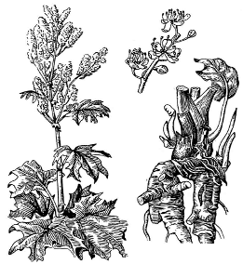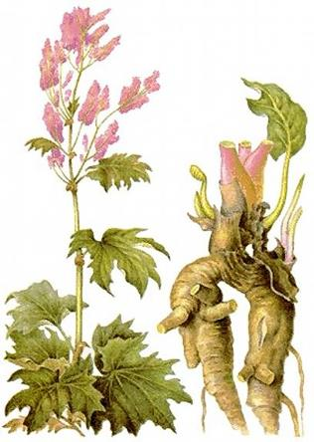
Fig.Rheum palmatum var. tanguticum

Plants.—Tall perennial herbs resembling garden rhubarb excepting for their lower growth and shape of their leaf blades. Their underground portion consists of a strong vertical voluminous rhizome with fleshy, spreading roots. The above-ground portion consists of a number of long petioled fleshy leaves that arise from the rhizome in the spring, and flower shoots bearing elongated leafy panicles that are crowded with greenish-white, white to red flowers. The lamina is cordate to somewhat orbicular, entire or coarsely dentate (Rheum officinale) or palmately lobed (R. palmatum) or deeply incised (R. tanguticum); with prominent reddish veins on the underside. The flowers are small, trimerous, and grouped into a large panicle. The fruit is an achene with 3 broad thin wings and surrounded at its base by the remains of the perianth.
MPM Description. According to the EP, The appearance is variable: disc-shaped pieces up to 10 cm in diameter and 1 cm to 5 cm in thickness; cylindrical pieces: oval or planoconvex pieces. The surface has a pinkish tinge and is usually covered with a layer of brownish-yellow powder. It shows, especially after moistening, a reticulum of darker lines. This structure causes the marbled appearance of the drug. The fracture is granular. The transverse section of the rhizome shows a narrow outer zone of radiating brownish-red lines. These medullary rays are crossed perpendicularly by a dark cambial ring. Inside this zone is a ring of small star-spot formations of anomalous vascular bundles. The root shows a more radiate structure.
The odour is aromatic. The taste is characteristically bitter.
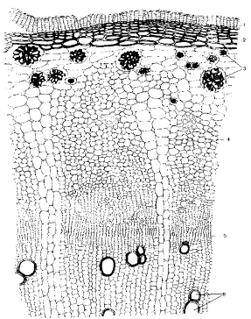
Fig.13.10 Cross section of Radices Rhei. 1 – Cork; 2 – phelloderm; 3 – aggregate crystals of calcium oxalate; 4 – medullary rays; 5 – cambium; 6 – xylem
Microscopical Characters. —The rhizomes of R. palmatum and R. officinale are similar in structure except for the size and distribution of the abnormal vascular bundles, 'star spots', of the pith.
Transverse sections of both, after peeling, show phloem on the outside, cambium, radiate wood and a pith with star spots. In R. palmatum the latter are relatively small (about 2,5 mm) and most of them are arranged in a continuous ring, in R. officinale the 'star spots' are larger (about 4 mm) and are irregularly scattered.
In the palmatum type the medullary rays are only about 6 cells deep, but in the officinale type they may be as much as 200 cells deep. This difference accounts for the fact that the surface of the officinale type gives the appearance of parallel red and white lines rather than a reticulation. In both species the appearance of the transverse surface varies according to the depth of peeling, which may extend into the radiate wood or even into the pith.
According to the EP, The powder is orange to brownish-yellow. The powder shows the following diagnostic characters: large calcium oxalate cluster crystals, which may measure more than 100 μm, and their fragments; reticulately thickened non-lignified vessels measuring up to 175 μm. Numerous groups of rounded or polygonal, thin-walled parenchyma cells. Sclereids and fibres are absent. The powder shows simple, rounded or compound (2 to 4) starch granules with a star-shaped hilum.
Constituents.—Anthraquinones without a carboxyl group (e.g. chrysophanol, aloe-emodin, emodin and emodin monomethyl ether, or physcion), their glycosides (e.g. chrysophanein and glucoaloe-emodin); anthraquinones with a carboxyl group (e.g. rhein and its glycoside, glucorhein). Anthrones or dianthrones of chrysophanol, or emodin or aloe-emodin, or physcion. The dianthrone glucosides of rhein (sennosides A and B), and the oxalates of these (sennosides E and F). In the dry drug, the chief constituent (60-80%) are anthraquinone glycosides, namely emodin, physcion, aloe-emodin, and chrysophanol glycosides. They occur alongside di-(9,C-glucosides of the monomeric reduced forms (rheinosides A-B [anthranols] and C-D [anthrones]), and of dimeric reduced forms (particularly sennosides A-D). The level of oxidized forms is maximal in the summer and almost nil in the winter; the interconversion between the two forms is very rapid (three weeks). In addition to the above purgative compounds, rhubarb contains astringent compounds, mainly hydrolyzable tannins (up to 12%), such as glucogallin, free gallic acid, (-)-epicatechin gallate and cathecin. Rhubarb also contains starch and calcium oxalate.
According to the EP, It contains not less than 2.2 per cent of hydroxyanthracene derivatives, expressed as rhein, calculated with reference to the dried drug.
Pharmacological Action. Uses.—Rhubarb remains in use as a laxative and an astrigent, especially as a powder. Rhubarb is used (as a purified dry extract combined with salicylic acid) for the local adjunctive treatment of inflammations and for infections of the oral cavity mucosa (irritations due to gingivitis or periodontitis). According to the 1998 French Explanatory Note, it is traditionally used for children's teething pains.

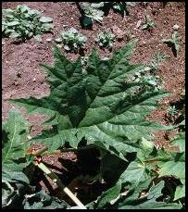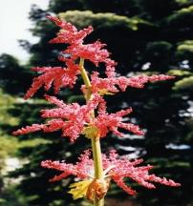

Rumex confertus

The root of the sorrel horse - Radix Rumicis

Щавель конский - Rumex confertus Willd. Sorrel horse - Rumex confertus Willd.

Семейство гречишные - Polygonaceae Buckwheat family - Polygonaceae

Многолетнее травянистое растение с коротким толстым слаборазветвленным, многоглавым корневищем.Botanical characteristics. Perennial herb with a short thick many-headed rhizome. Стебли прямостоячие, чаще одиночные, голые, бороздчатые, высотой до 1,5 м и толщиной до 2 см, ветвистые в верхней части. Stems erect, usually single, glabrous, grooved, up to 1.5 m thick and up to 2 cm, branched at the top. Листья очередные, розеточные и нижние стеблевые удлиненно-треугольно-яйцевидные с сердцевидным основанием, тупые, по краю волнистые, длиной до 25 см и шириной до 12-13 см; верхние - меньшего размера, яйцевидно-ланцетовидные. Leaves alternate, rosette and lower stem elongated, triangular-ovate with cordate base, obtuse at the edge of the wavy, up to 25 cm and a width of up to 12-13 cm, upper - a smaller, ovate-lanceolate. Все листья черешковые, верхние - на коротких черешках. All leaves petiolate, upper - on short stalks. При основании черешков образуется пленчатый раструб красноватого цвета, охватывающий стебель. At the base of stalks formed filmy mouth reddish color covering the stem. Листья снизу, особенно по жилкам, короткоопушенные. Leaves from the bottom, especially along the veins, korotkoopushennye. Цветки мелкие, зеленоватые, с простым шестилепестным околоцветником, собраны небольшими мутовками в узкое, длинное и густое метельчатое соцветие. Flowers small, greenish, with a simple shestilepestnym perianth, gather a small whorl of narrow, long and dense paniculate inflorescence. Плоды - трехгранные, овальные, коричневые орешки длиной 4-5 мм, заключенные в три разросшиеся доли околоцветника. Fruits - triangular, oval, brown nutlets 4-5 mm long, enclosed in three overgrown parts of perianth. Цветет в мае-июне. Flowering in May-June. Плоды созревают в июне-июле. The fruits ripen in June and July.

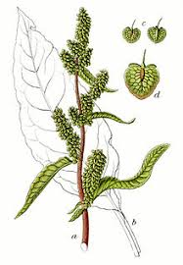 Щавель конский - евразийский вид.
Distribution. Sorrel horse - a Eurasian species. В европейской части страны распространен повсеместно, кроме Крайнего Севера. In the European part of the country is widespread, except the Far North. Произрастает в лесной и лесостепной зонах, по долинам рек заходит в степную зону. Grows in forest and steppe zones, river valleys comes in the steppe zone. Поселяется преимущественно на умеренно влажных и влажных почвах.
Habitat. Resides mainly in the temperate humid and wet soils. В поймах рек хорошо развивается при небольшом слое ила, переносит значительное заиление и кратковременное затопление, но не выдерживает заболачивания, поэтому отсутствует на низинных пойменных лугах. Found in forest meadows and clearings, roadsides, fields and orchards, in ravines, ditches, along the shores of lakes and weedy places. Чаще растет единичными экземплярами или небольшими группами, но иногда образует довольно густые заросли площадью в несколько гектаров. Корни щавеля конского заготавливают в августе-сентябре, в начале отмирания надземной части, или рано весной, в период отрастания растения, выкапывая лопатами.
Harvesting, primary processing and drying. Sorrel horse roots harvested in August-September, at the beginning of the withering away of the above-ground parts, or early spring, during the regrowth of plants, digging with shovels. Заготовке подлежат только крупные растения. Dried with good ventilation in attics or under the eaves, spreading a layer of 3-5 cm, occasionally turning. Можно сушить в сушилках при температуре 50-60°С. Can be dried in a dryer at a temperature of 50-60 ° C. Качество сырья регламентирует ВФС 42-1077-81. В корнях щавеля конского содержится до 4% произвольных антрахинона, в состав которых входят хризофановая кислота и хризофанол; дубильные вещества пирокатехиновой группы (до 15%, т. е. больше, чем в ревене); флавоноиды, кофейная кислота, эфирное масло, смолы, железо (в виде органических соединений).
Chemical composition. Sorrel horse in the roots contain up to 4% of arbitrary anthraquinone, which include hrizofan acid and hrizofanol; tannins of pirokatehin groups (up to 15%, ie, more than rhubarb), flavonoids, caffeic acid, essential oil , resin, iron (in the form of organic compounds). В плодах обнаружены производные антрахинона и дубильные вещества. In fruits found anthraquinone derivatives and tannins. В листьях найдены флавоноиды (гиперозид, рутин и др.), аскорбиновая кислота и каротин. The leaves were found flavonoids (hyperoside, rutin and others), ascorbic acid and carotene. Все части растения содержат большое количество оксалата кальция. All plant parts contain large amounts of calcium oxalate. Количество антрагликозидов в нем хотя и меньше, чем в ревене, но все же достаточно большое, чтобы считать щавель ценным лекарственным сырьем. Number of antraglikozides it although less than in the rhubarb, but still large enough to hold the dock valuable medicinal raw materials. Сырье упа ковывают в мешки по 20-30 кг. Отвар и порошок.
Drugs. Decoction and powder. Щавель конский употребляют в виде отваров и порошка для лечения колитов, энтероколитов, геморроя.
Application. Sorrel horse use in the form of decoction, and powder for the treatment of colitis, enterocolitis, haemorrhoids. В малых дозах они оказывают вяжущее действие, в больших - действуют как слабительное. In small doses, they exert astringent in the large - act as a laxative. Препараты щавеля противопоказаны при мочекаменной болезни почек. Drugs are contraindicated in sorrel kidney stone disease. В народной медицине показаний для назначений лекарств из щавеля значительно больше, а в качестве сырья используют не только подземные части растения, но и плоды, цветки, реже листья. In folk medicine, the indications for prescribing of sorrel is much larger, and as a raw material used not only the underground parts of plants, but also fruits, flowers, rarely leaves. Листья щавеля используют в народной медицине как витаминное при цинге, в начальной стадии гингивита, стоматита. Sorrel leaves are used in folk medicine as a vitamin for scurvy in the early stages of gingivitis, stomatitis.
Длительное применение не рекомендуется (как и других растений, содержащих антрахиноны). Prolonged use is not recommended (and other plants containing anthraquinones). Препараты щавеля противопоказаны при болезнях почек.Drugs are contraindicated sorrel renal diseases.

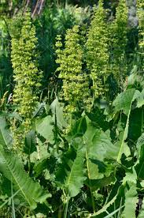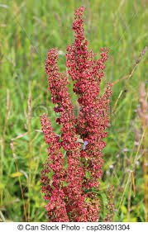
Rubia tinctorum

Rhizome and root of the madder -Rhizomata et radix Rubiae - Корневище и корень марены Rhizomata et radix Rubiae

Марена красильная - Rubia tinctorum L. Madder dyeing - Rubia tinctorum L.
Марена грузинская - Rubia iberica Fisch. The Madder family Семейство мареновые - Rubiaceae - Rubiaceae

Botanical Origin.—Rubia tinctorum L. (Engl. – European Madder). Family – Rubiaceae.
Part Used.—Rhizomata et radices Rubiae consists of dried rhizomes and roots of Rubia tinctorum L., Rubiaceae.
Habitat.—The plant is indigenous to Southern Europe, Western Asia and North Africa and is cultivated elsewhere.
Plant.—The perennial plant grows from 60 to 100 cm high. The rhizome creeps widely underground. The stem is quadrangular with backward turning prickles at the edges. The stems are at times so thin that they are more descendent than erect. The leaves are in whorls, in fours below, in sixes above. They are oblong to lanceolate with 1 rib and are protrudingly reticulate beneath. The small yellowish-green flowers are in loose, leafy, long-peduncled terminal or axillary cymes. The margin of the calyx is indistinct, 4 to 5 sectioned and has a tip which is curved inward. There are 5 stamens and an inferior ovary. The fruit is a black, pea-sized glabrous, smooth drupe containing 2 seeds.

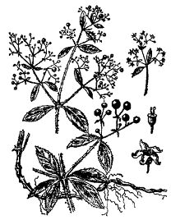 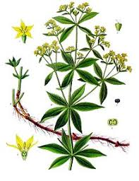.
Fig. Rubia tinctorum

MPM Description.–The drug occurs as pieces of the cylindrical rhizome. The pencil-thick rhizome horizontal, long, criping, cylindrical, multi-headed, the segments from 3 to 20 cm in length and about 1 cm in diameter; externally reddish. In cross section red wood can be observed. Fracture is even, odour indistinct, taste bitterish.
Microscopical Characters.–Cork of several layers of rectangular cells. The medullary rays feebly marked. Parenchyma cells of cortex contain raphides of calcium oxalate. Cambium zone is narrow. Xylem cells are scattered in small groups.

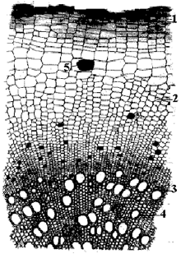

Fig. Cross section of Rubia tinctorum root.
1 – Cork; 2 – cortex; 3 – cambium; 4 – xylem; 5 – raphides of calcium oxalate

MPM Description.–The drug occurs as pieces of the cylindrical rhizome. The pencil-thick rhizome horizontal, long, criping, cylindrical, multi-headed, the segments from 3 to 20 cm in length and about 1 cm in diameter; externally reddish. In cross section red wood can be observed. Fracture is even, odour indistinct, taste bitterish.
Microscopical Characters.–Cork of several layers of rectangular cells. The medullary rays feebly marked. Parenchyma cells of cortex contain raphides of calcium oxalate. Cambium zone is narrow. Xylem cells are scattered in small groups.
Constituents.—The drug contains up to 60 different methylhydroxyanthraquinones (the total content of anthraquinones approximately 3%), alizarine and its bioside ruberithrinic acid, lucedine and its bioside lucidinprimverosine, rubiadine with rubiadinprimverosine, purpurine-3-carbonilic acid; also occur purpurine, xanthopurpurine and methylic ester of alizarine.
Pharmacological Action. Uses.—Alizarine derivatives dissolve kidney stones (lytolitics). Madder extract and powder, Cystenalum and Marelinum have lytolitic, spasmolytic and diuretic activity.

